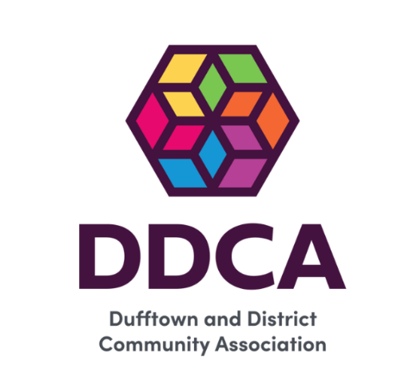

Dufftown and District Microgrants
Fund Report 2025-2026
Dorenell Windfarm Community Benefit Fund



- Introduction
The Dorenell Community Benefit Fund supports a Micro Grant Scheme for the Dufftown and District area. The Dufftown and District Community Association (DDCA) receives an annual allocation to distribute grants to local groups and individuals, supporting a wide range of charitable activities that benefit the community.
Applications can be submitted by individuals or groups via a straightforward form available on the DDCA website, or directly through the Community Development Officer. Applicants are asked to outline their proposed activity and the anticipated community benefit.
The fund operates on a rolling basis throughout the year, with applications reviewed monthly by the DDCA Board of Trustees. Funding decisions are made at scheduled board meetings, ensuring a consistent and transparent approach to grant allocation.
Between 30 April 2025 and 31 March 2026, a total of £5,419.04 was awarded through the Dufftown and District Micro Grant Fund.
Grants of up to £500 are available for individuals, and up to £1,000 for community groups.

1.1 About the Dufftown and District Community Association
Dufftown and District Community Association (DDCA) is a registered charity (SC023622). Established in 1995 through the merger of two local groups, it has grown to become the largest charity serving the Dufftown and District area.
The DDCA’s charitable purposes are to:
- Relieve the poverty of the local population of Dufftown and District.
- Advance the education of the local population of Dufftown and District.
- Provide, fundraise for, manage, or assist in the provision of facilities and/or activities in the interests of social welfare, including recreation and leisure.

2.0 Awards Summary
Date | Applicant | Purpose | Award
29.04.25 | Dufftown in Bloom | Plants | £1000
29.04.25 | Pheonix Kettlebells | Kettlebells | £1000
01.05.25 | Royal British Legion, Dufftown | VE Event | £250
27.05.25 | Mortlach Memorial Hall | Floor Cleaner | £1000
26.08.25 | Keith & Dufftown Railway | Marquee for Silver Jubilee Gala | £1000
26.08.25 | DDCA | Defibrillator Pads | £110
30.09.25 | Paths Group | Signs for Paths | £59.04
30.09.25 | Football Club | Strimmer and Grass keeping equipment | £1000
 |  | Total | £5,419.04

3.0 Impact
The Dufftown and District Micro Grant Fund continues to make a meaningful difference across the community, supporting a wide range of local initiatives, individuals, and groups. While the grants awarded are relatively small in value, their impact is significant, helping to reduce barriers, create opportunities, and strengthen community connections.
This section highlights some of the key outcomes and benefits achieved over the past year, demonstrating how targeted, accessible funding can enable positive change at a local level.

3.1 Mortlach Memorial Hall, Dufftown
Mortlach Memorial Hall received funding to purchase a new floor cleaning machine. Previously, the large hall areas had to be mopped manually by volunteers or the cleaner, which was a time-consuming task, particularly after events.
This investment has significantly improved efficiency, reducing the time required for cleaning and allowing volunteer time to be redirected to other important activities within the hall.
“We are very grateful to Dufftown and District Community Association for their support in helping to purchase this machine.” Jean MacDonald MMH
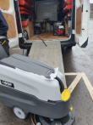
Lavor Dynamic 45 B Scrubber Dryer

3.2 Dufftown Football Club
Dufftown Football Club received funding to purchase a new strimmer, making maintenance of the pitch and surrounding areas much easier and more efficient. The new equipment helps keep the playing surface in excellent condition and the grounds looking well cared for, enhancing both the experience for players and the wider community. This investment has also fostered a sense of pride in Dufftown, as volunteers and club members work together to maintain facilities that the whole community can enjoy.
“Dufftown football club received a microgrant, and were truly grateful. The funds were put on the purchase of a new strimmer and the remainder towards a hand mower The football club is always appreciative of small grants and donations from the local community” Harry Officer, Chairperson
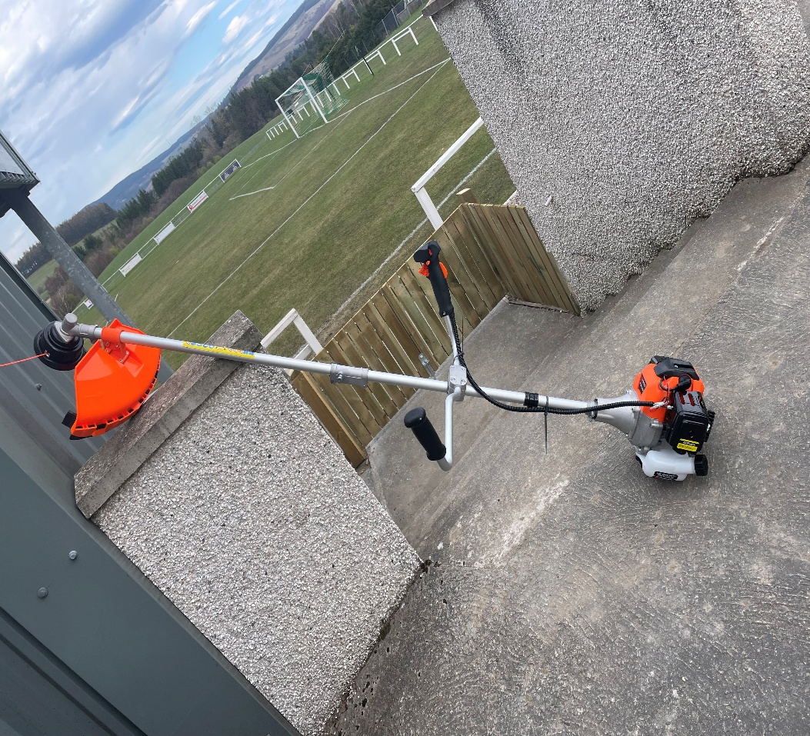

3.3 Pheonix Kettle Bells
Phoenix Kettlebells received funding to purchase new kettlebells for the club. This has enabled participants to attend classes without needing to purchase their own equipment, helping to remove financial barriers to participation.
Access to these sessions supports increased involvement in physical activity, which is widely recognised as benefiting both physical and mental health, as well as overall wellbeing.
“Phoenix Kettlebells were delighted to receive a grant for equipment. This has had a huge impact allowing the club to expand to run circuit training classes as well as kettlebells classes in the Dufftown Community Centre. With classes available 4 days a week it gives adults of all ages to participate in exercise locally. If you want to compete the club can help with an individual training plan which could take you from a total beginner to competing internationally.” Angharad Rogers.

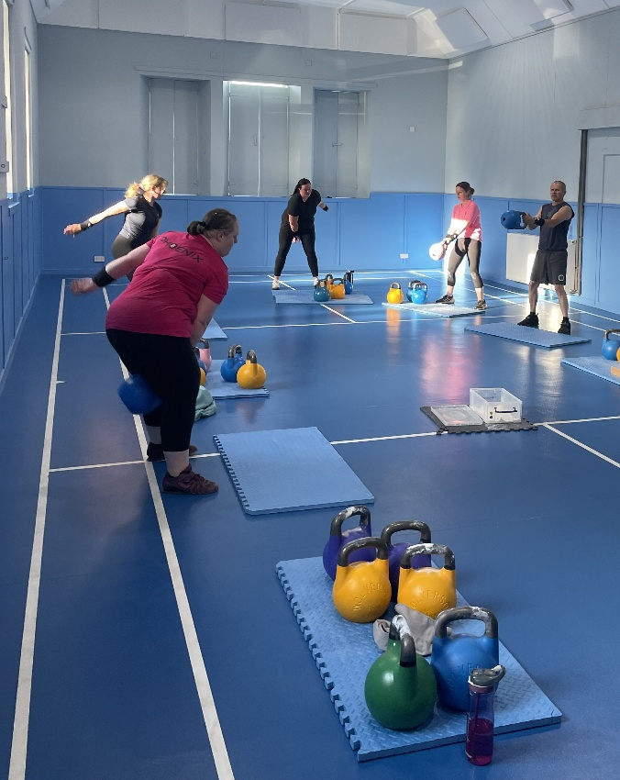

3.4 The Royal British Legion, Dufftown – VE day celebration.
The Legion received funding from Dufftown and Glenrinnes Micro Grants to support their VE Day celebration event in May 2025. It was important to the Legion that this was a free event for families to enjoy, and the funding was used towards children’s entertainment, an ice cream van, and a BBQ. Any remaining costs for the event were covered by the Legion.
